1. 
2. If you have installed Docker on your machine, just open terminal and type the command “docker”.
3. This would lunch the Docker Client. Then it would execute and afterwards this process would exit.
4. See it is listing all the commands available for you to use with Docker Client.
5. 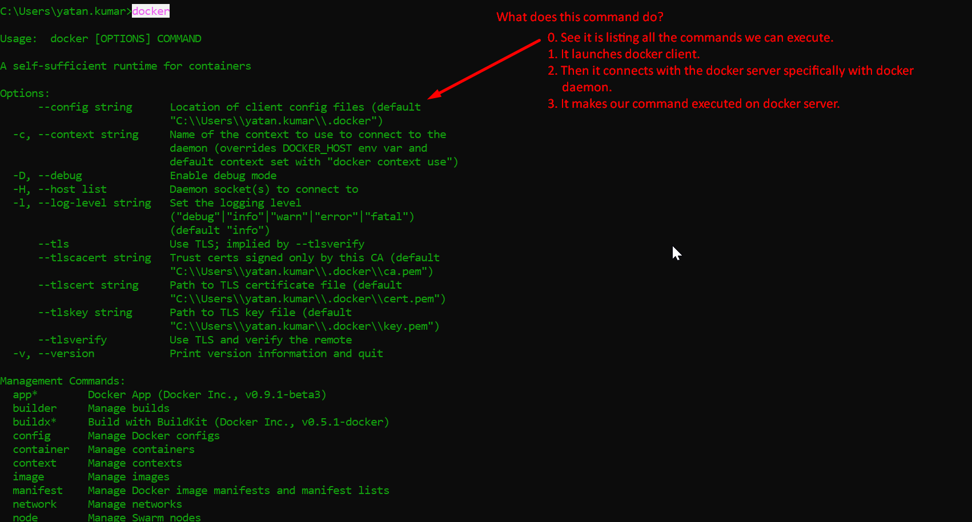  
   ps command 🡺 Process Status
6. 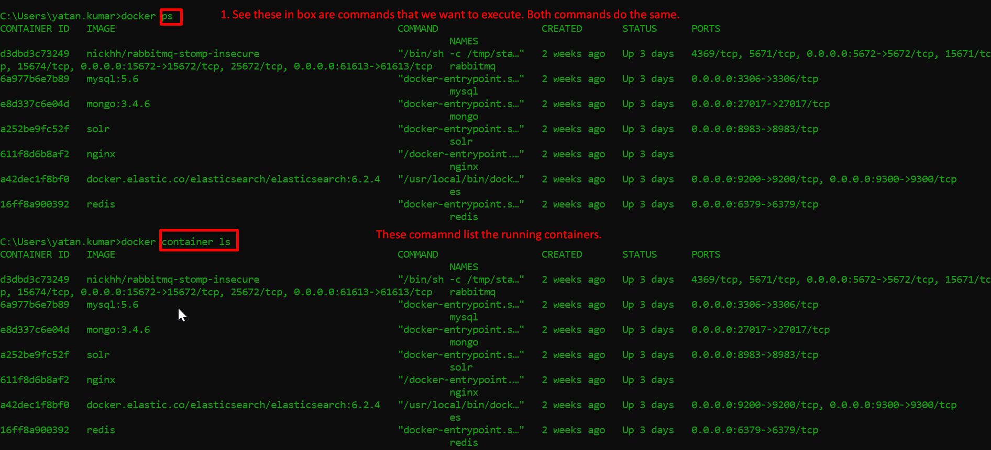
7. 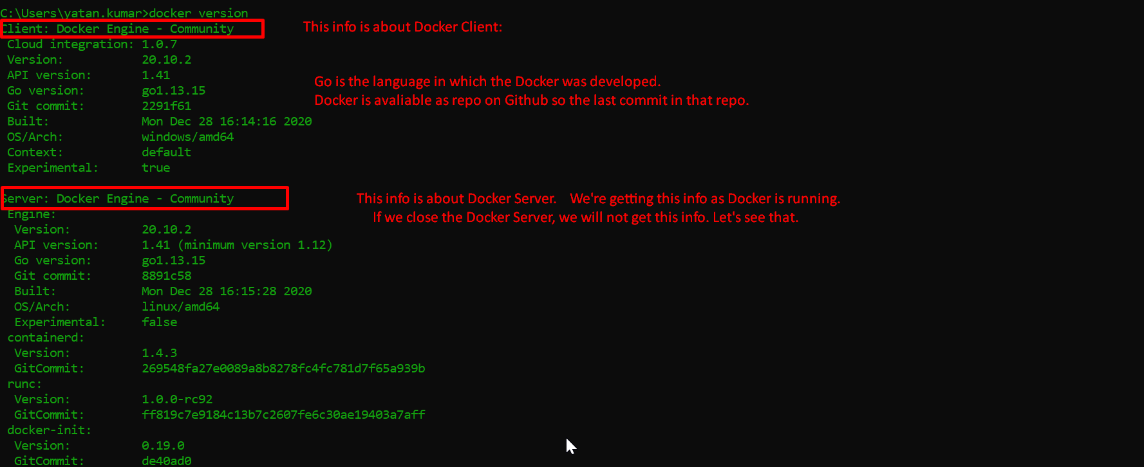
8. 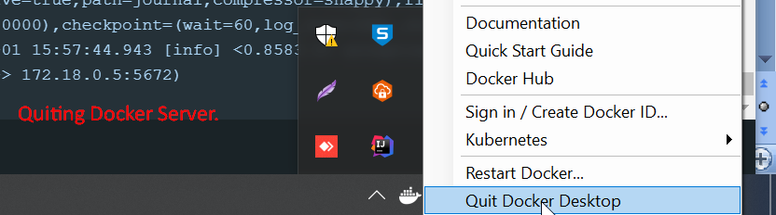
9. 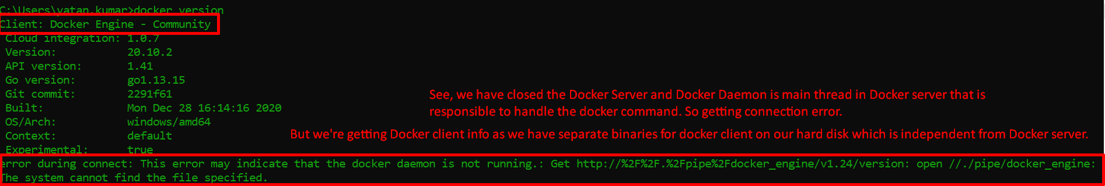
10. There are other executables in docker/bin. Let’s see them.
11. 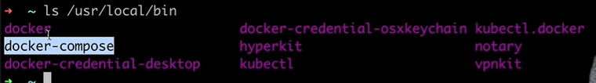
12. **Docker-compose**: To run/launch multiple containers in one go.
13. That is all about Docker Client
    1. Docker client is separate from Docker Server.
    2. Docker Client is used to execute Docker Commands on Docker Server.